Ideation Phase

Empathize & Discover

Date | 31January2025
Team ID
Project Name | Advancing Nutrition Science through GeminiAI (NutriGen AI)
Maximum Marks | 4Marks

Empathy Map Canvas:
Target User Persona: The Health-Conscious Individual (e.g., busy professionals, fitness enthusiasts, or people managing specific dietary restrictions and allergies).
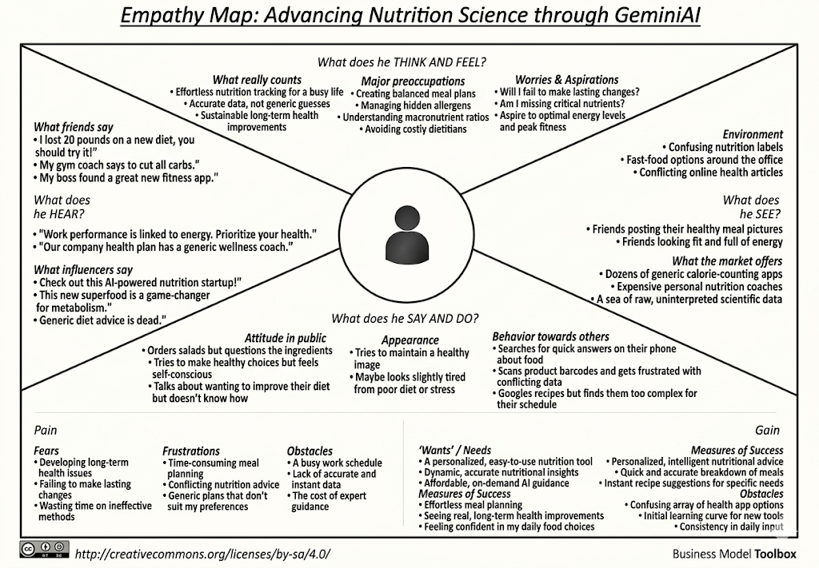
1. Who are we empathizing with?
- Individuals who want to improve their diet but lack the time or nutritional knowledge to do so effectively.
- People with specific dietary restrictions (e.g., allergies, gluten-free, vegan) or health conditions who need highly customized meal plans.
- Users who cannot afford expensive, traditional, one-on-one nutrition coaching.
2. What do they need to DO?
- Easily understand the macronutrient and micronutrient breakdown of their daily meals.
- Find recipes and generate grocery lists that strictly adhere to their personal taste preferences and health needs.
- Get quick, reliable answers to nutritional questions without sifting through conflicting articles online.
3. What do they SEE?
- Confusing and complex nutrition labels on packaging.
- Overwhelming and often contradictory diet advice on social media and the internet.
- High price tags for personalized dietitians or virtual wellness coaches.
4. What do they SAY?
- "I want to eat healthier, but meal planning takes too much time and effort."
- "I have a nut allergy and am lactose intolerant; finding varied, tasty recipes is a nightmare."
- "I wish I had someone to just tell me if this snack fits my daily calorie and protein goals."
5. What do they DO?
- Download generic calorie-counting apps but abandon them because they require too much manual data entry.
- Guess portion sizes and nutritional values, leading to missed health goals.
- Spend hours searching for recipes, only to realize they are missing key ingredients.
6. What do they HEAR?
- Doctors or fitness trainers emphasizing that "diet is 80% of the work."
- Friends or influencers promoting the latest fad diets, which may not be scientifically sound or sustainable.
7. PAINS (Frustrations & Obstacles)
- Time: Planning balanced meals and creating grocery lists for a whole week is tedious.
- Confusion: Translating complex nutritional data into actionable, everyday food choices is difficult.
- Cost: Professional, tailored nutrition advice is financially out of reach for many.
8. GAINS (Success & Needs)
- Convenience: Instant, AI-generated meal plans and grocery lists save hours of time.
- Clarity: Dynamic insights (like barcode scanning) make understanding food intake effortless.
- Support: Having a 24/7 Gemini-powered virtual coach provides motivation, sustainable lifestyle changes, and long-term health improvements.
